End-to-End Deep Learning Automatic Speech Recognition for Spanish in Gong

Abstract: End-to-End Deep Learning approach greatly simplifies the pipeline for building Automatic Speech Recognition systems. Transformer-based model architectures, which accept acoustic-features into Encoder and produce language-tokens by Decoder are robust and close to SOTA models for ASR task. We applied this architecture to Spanish language using publicly available datasets and Gong’s Spanish datasets. We studied the quality of datasets, achievable performance in terms of WER and inference time, and tuned the model for Gong data.

- Introduction
Current production systems [“End-to-end speech recognition with word-based rnn language models”] “lean heavily on the scaffolding of complicated legacy architectures that grew up around traditional techniques, including hidden Markov models (HMMs), Gaussian mixture models (GMMs), hybrid HMM/deep neural network (DNN) systems, and sequence discriminative training methods [“The Kaldi speech recognition toolkit”]. These systems also require hand-made pronunciation dictionaries based on linguistic assumptions, extra training steps to derive context-dependent phonetic models, and text preprocessing such as tokenization for languages without explicit word boundaries. Consequently, it is quite difficult for non-experts to develop ASR systems for new applications, especially for new languages”
During the recent years several types of end-to-end architecture for ASR were proposed, “such as Connectionist Temporal Classification (CTC) [“Towards End-to-End Speech Recognition with Recurrent Neural Networks”], recurrent neural network (RNN) transducer [“SPEECH RECOGNITION WITH DEEP RECURRENT NEURAL NETWORKS”], attention-based encoder decoder [“Attention-Based Models for Speech Recognition”], and their hybrid models”. Recent additions to this list include Facebook’s Wav2Letter, Nvidia’s Jasper and QuartzNet, (Mazzila’s DeepSpeach? TBD: check what’s their architecture), and Transformer based Sequence-to-Sequence models.
Transformer based Sequence-to-Sequence models showed “surprising superiority” in multiple ASR benchmarks in comparison with RNN” [“A COMPARATIVE STUDY ON TRANSFORMER VS RNN IN SPEECH APPLICATIONS”, S. Karita et al. 2019].
“One of the major difficulties when applying Transformer to speech applications is that it requires complex configurations(e.g., optimizer, network structure, data augmentation) than the conventional RNN based models”. The authors of [“A COMPARATIVE STUDY ON TRANSFORMER VS RNN IN SPEECH APPLICATIONS”, S. Karita et al. 2019]] created a kaldi-stile reproducible recipes for Open Source toolkit ESPnet, which greatly simplifies the configuration and working pipline. We based our experiments on this toolkit.

The contributions of our work are
- We conducted a comparative study of model performance on publicly available Spanish Datasets, and Gong’s Spanish Datasets
- We (partially TBD) performed hyperparameters search for each dataset (see [“Training Tips for the Transformer Model”, M. Popel et al.])
- We developed reproducible pipeline for experiments on multiple datasets. This includes data loading and transformation and transfer of model components
- We tuned the model for Gong’s dataset
- We outlined the directions for the future work to further improve the WER and inference time

- ASR E2E Sequence to Sequence Pipeline
We use ESPnet framework and their implementation of Hybrid CTC/attention based ASR
Below is the feature list of ASR module of ESPnet
[======================= from https://github.com/espnet/espnet#asr-results
ASR: Automatic Speech Recognition
- State-of-the-art performance in several ASR benchmarks (comparable/superior to hybrid DNN/HMM and CTC)
- Hybrid CTC/attention based end-to-end ASR
  - Fast/accurate training with CTC/attention multitask training
  - CTC/attention joint decoding to boost monotonic alignment decoding
  - Encoder: VGG-like CNN + BiRNN (LSTM/GRU), sub-sampling BiRNN (LSTM/GRU) or Transformer
- Attention: Dot product, location-aware attention, variants of multihead
- Incorporate RNNLM/LSTMLM/TransformerLM/N-gram trained only with text data
- Batch GPU decoding
- Transducer based end-to-end ASR
  - Available: RNN-Transducer, Transformer-Transducer, mixed Transformer/RNN-Transducer
  - Also support: attention mechanism (RNN-decoder), pre-init w/ LM (RNN-decoder), VGG-Transformer (encoder)
- CTC forced alignment
]============================ from https://github.com/espnet/espnet#asr-results
Our current work is based on Hybrid CTC/attention based end-to-end ASR module from ESPnet.

TBD: add a section describing
1) Wav2Letter (12 (?) convolution layers)
2) Nvidia’s Jasper (convolution layers with residual connections for handling of vanishing gradients) and
3) QuartzNet (simplified Jasper).

  - Transformer-based architecture for ASR
S2S model consists of two neural networks: Encoder and Decoder

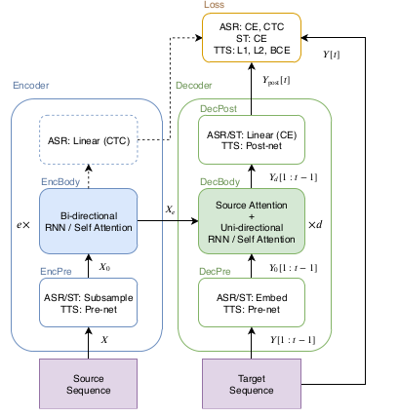
Fig. 1. Sequence to Sequence architecture in speech applications.
TBD: redraw for ASR only

“Attention mechanism emits source frame-wise weights to sum the encoded source frames as a target frame-wise vector to be transformed with the prefix . We refer to this type of attention as “encoder-decoder attention”.”
“Transformer learns sequential information via a self-attention mechanism instead of the recurrent connection employed in RNN.”

“In our ASR framework, the S2S predicts a target sequence Y of characters or SentencePiece [“SentencePiece: A simple and language independent subword tokenizer and detokenizer for Neural Text Processing”, T. Kudo, J. Richardson] from an input sequence of logmel filterbank speech features”.

“For ASR, an encoded sequence can also be used for source-level frame-wise prediction using connectionist temporal classification (CTC)”
TBD: Looks like “Linear CTC” block in the Encoder outputs the char-probabilities vectors per each time-frame. The question is how is it related to the intermediate sequence?

  - Attention Layers in Transformer
“Transformer consists of multiple dot-attention layers:
,
where and are inputs for this attention layer, is the number of feature dimensions, is the length of ,and is the length of and . We refer to as the attention matrix. Vaswani et al., in their original paper, considered these inputs to be query and set of key-value pairs respectively.
”
“In addition, to allow the model to deal with multiple attentions in parallel, Vaswani et al. extended this attention layer to multi-head attention (MHA):
,
,
where
”

  - Self-Attention Encoder

  - Self-Attention Decoder

  - Encoder architecture
“The source X in ASR is represented as a sequence of 83-dim log-mel filterbank frames with pitch features [“A pitch extraction algorithm tuned for automatic speech recognition”, P. Ghahremani et al.]. First, EncPre(·) trans-forms the source sequence X into a subsampled sequence “Advances in Joint CTC-Attention based End-to-End Speech Recognition with a Deep CNN Encoder and RNN-LM” T. Hori et al.by using two-layer CNN with 256 channels, stride size 2 and kernel size 3 in [“SPEECH-TRANSFORMER: A NO-RECURRENCE SEQUENCE-TO-SEQUENCE MODEL FOR SPEECH RECOGNITION”, L. Dong et al.], or VGG-like max pooling in [“Advances in Joint CTC-Attention based End-to-End Speech Recognition with a Deep CNN Encoder and RNN-LM” T. Hori et al.], where is the length of the output sequence of the CNN. This CNN corresponds to EncPre(·) in Eq. (1). Then, EncBody(·) transforms sub att into a sequence of encoded features for the CTC and decoder networks.”

  - Decoder architecture
“The decoder network receives the encoded sequence and the prefix of a target sequence of token IDs: characters or SentencePiece [“SentencePiece: A simple and language independent subword tokenizer and detokenizer for Neural Text Processing”, T. Kudo, J. Richardson]. First, DecPre(·) in Eq. (3) embeds the tokens into learnable vectors. Next, DecBody(·) and single-linear layer DecPost(·) predicts the posterior distribution of the next token prediction given and .”
  - Training and Decoding
“During ASR training, both the decoder and the CTC module predict the frame-wise posterior distribution of Y given corresponding source X: and , respectively. We simply use the weighted sum of those negative log likelihood values:
, (14)
where α is a hyperparameter.
In the decoding stage, the decoder predicts the next token given the speech feature X and the previous predicted tokens using beam search, which combines the scores of ATT, CTC and the RNN language model (LM) [“Recurrent neural network based language mode”, T. Mikolov et al.] as follows:

, (15)
where is a set of hypotheses of the target sequence, and , are
hyperparameters.

TBD: use pytorch and tensorboard to visualize network topology

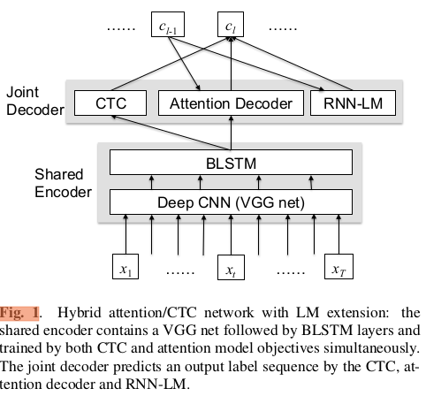

- Metrics
WER and Inference-time

- Data Sources
TBD: put a table presenting all used datasets and their characteristics,
Inspect the datasets: the audios, the transcripts

Common Voice contains 148375 utterances, 120 hours, # speakers
Gong Unsupervised
Gong supervised – first pass
Gong supervised – second pass

- Parameters and Optimizations
TBD -explain:
elayers: 12
dlayers: 6
dunits: 2048, eunits: 2048 (feed-forward dimensions)
adim: 512 (attention dimension)
aheads: 8 (number of attention heads)

accum_grad: 4 see [“Scaling Neural Machine Translation”], https://github.com/pytorch/fairseq/blob/master/examples/scaling_nmt/README.md

see [“SPEECH-TRANSFORMER: A NO-RECURRENCE SEQUENCE-TO-SEQUENCE MODEL FOR SPEECH RECOGNITION”, L. Dong et al.] for the selection of the following params
dropout-rate: 0.1
transformer-lr: 10.0
transformer-warmup-steps: 25000

- Experiments
TBD:

- Model Tuning for Gong Data
TBD:

- Lab Journal / Training Details
TBD:
ESPnet tutorial: https://hackmd.io/s/rJ6TDZPeQ

- Results
TBD:
Publicly known results achieved in ESPnet are here https://github.com/espnet/espnet#asr-results

Table 1. Results ...TBD
 | 83.4 nm |  |  | 121.6 nm
Material | n | K |  | n | k
Ir | 1.182 | 0.865 |  | 1.450 | 1.040
MgF2 | 1.584 | 0.487 |  | 1.682 | 0.0627
Al | 0.09874 | 0.1915 |  | 0.0424 | 1.137
Mo | 0.98 | 1.08 |  | 0.78 | 1.03
C | 1.16 | 1.29 |  | 1.85 | 1.1

- Discussion
TBD:

- Conclusion and Future Work
In this paper, we evaluated...
Future work:
1) make comparison with other publicly available frameworks and network architectures in terms of WER and inference time
2) Improve the inference time based on ideas from “STREAMING AUTOMATIC SPEECH RECOGNITION WITH THE TRANSFORMER MODEL”, N. Moritz et al. and “Triggered attention for end-to-end speech recognition” N. Moritz
or find others ideas.
3) improve sw to simplify the experiments and analysis

The basic approach is to:
1) select high quality datasets and learning strategy with good signal using complex/heavy but robust tranformer model
2) simplify the model to achieve speed:
a) try simplified transformer (time-restricted self-attention for the encoder and triggered attention for the encoder-decoder attention mechanism),
b) Wav2Letter (12 convolution layers),
c) Nvidia’s Jasper (convolution layers with residual connections for handling of vanishing gradients) and
d) QuartzNet (simplified Jasper)

- Appendix

  - Screenshots

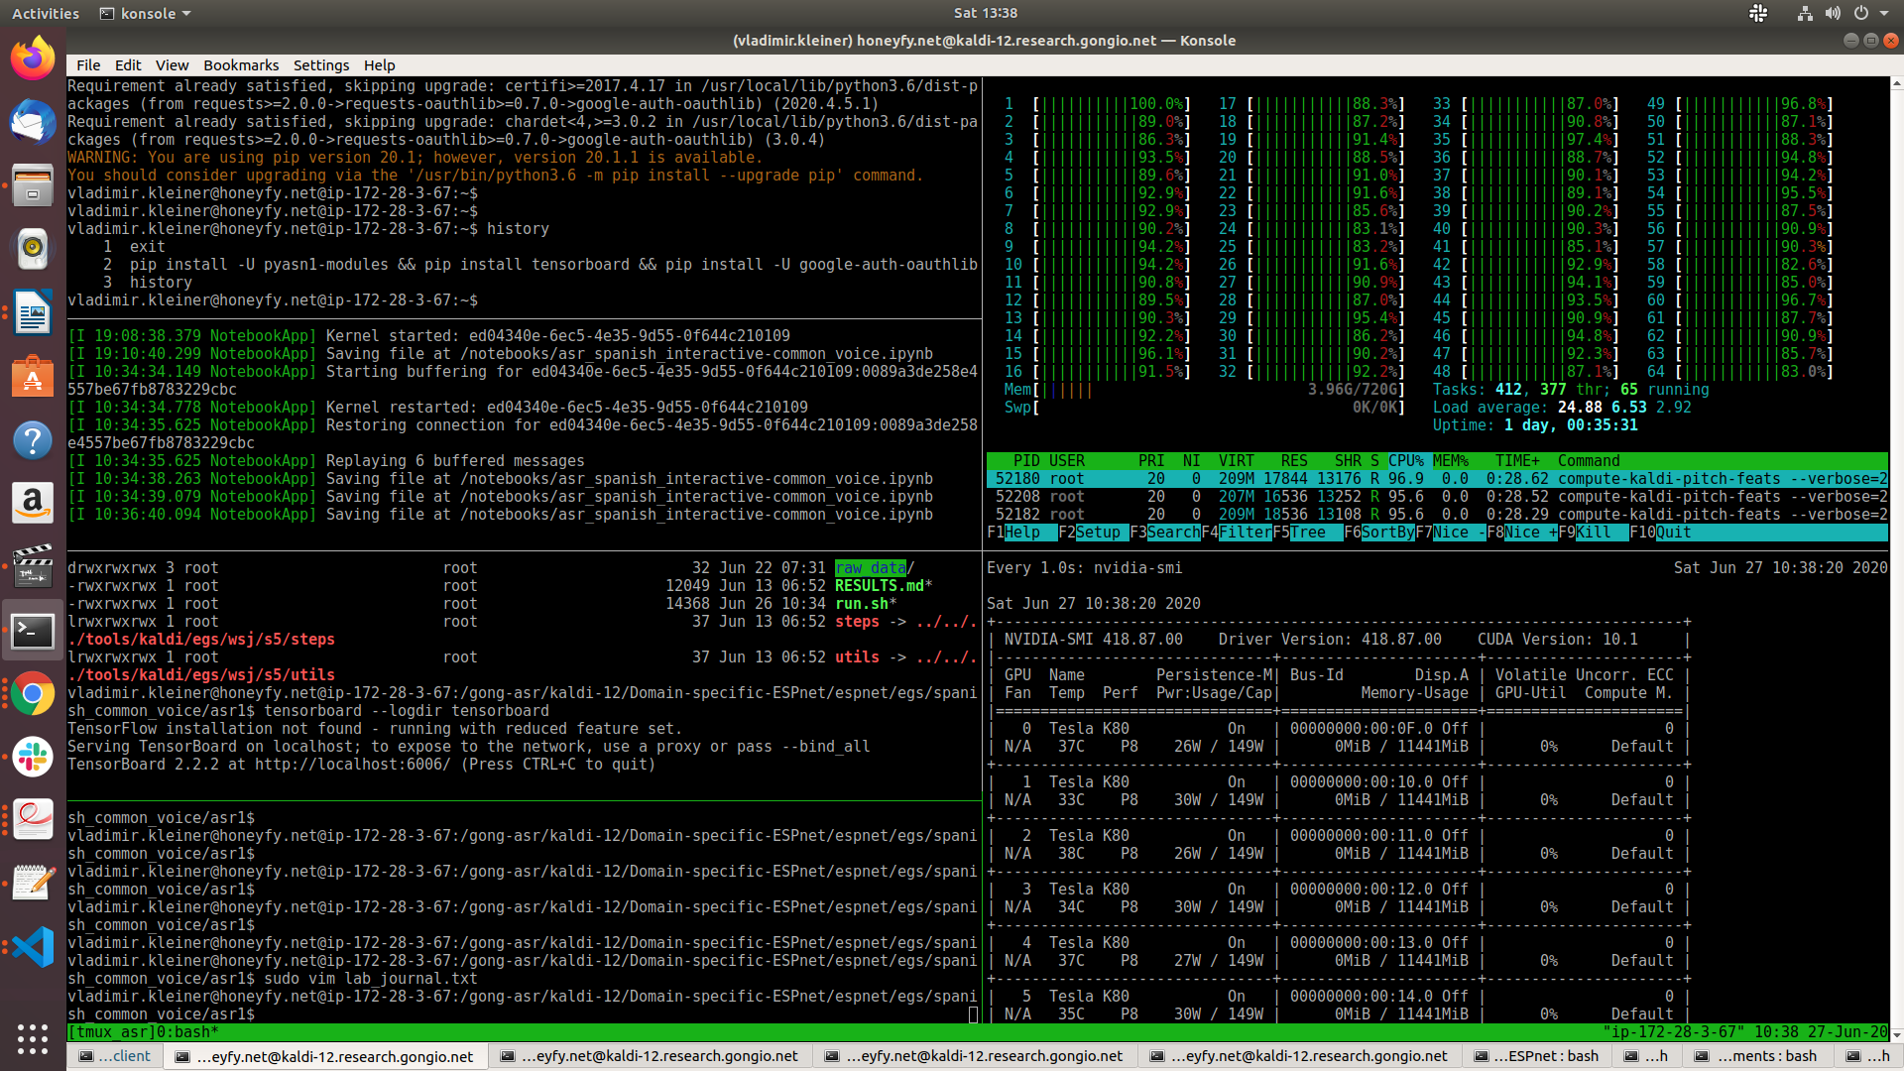
Fig. #. tmux terminal.

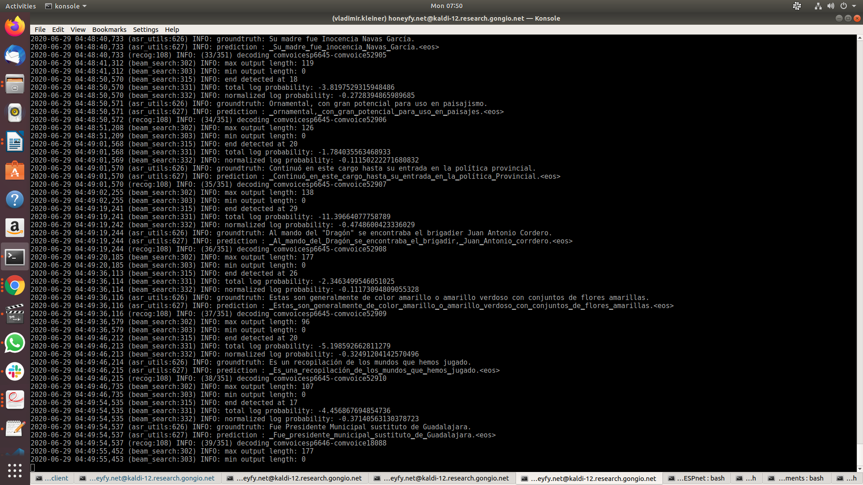
Recognition output

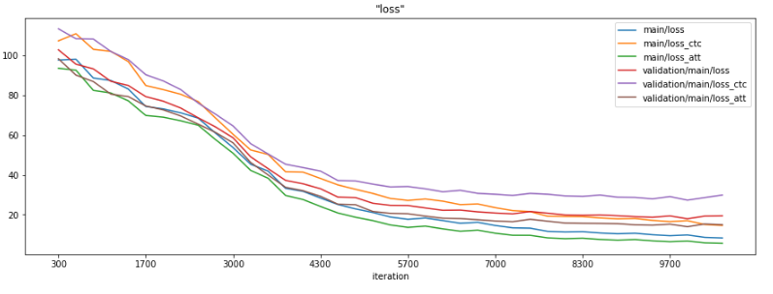

  - Plots for “Spanish Common Voice”

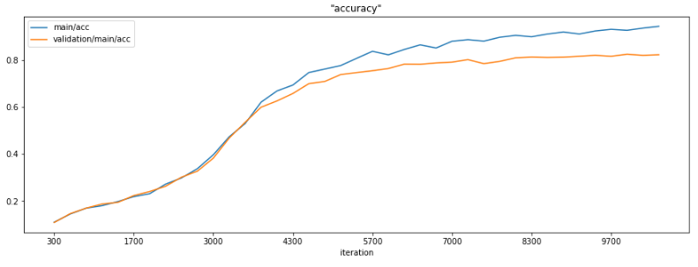
Fig. #. .

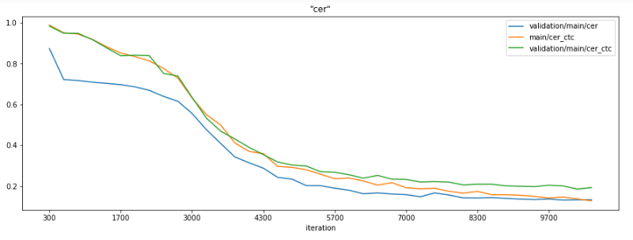
Fig. #. .

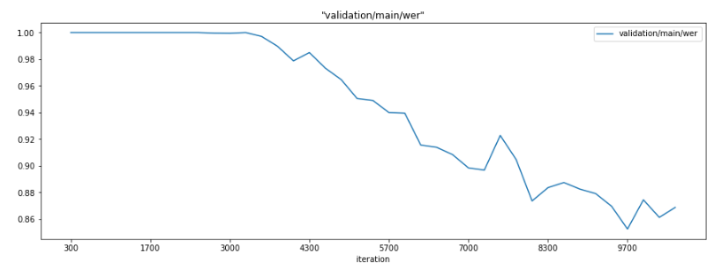

Fig. #. .

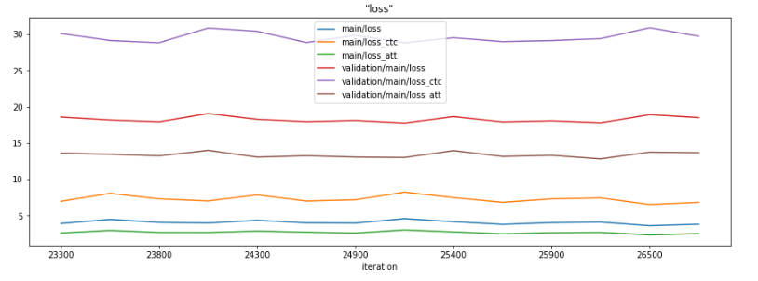
Fig. #. .

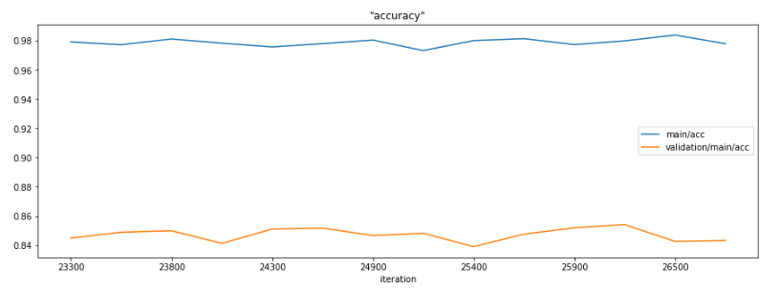
Fig. #. .
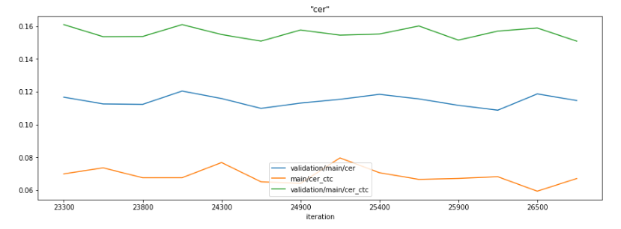
Fig. #. .

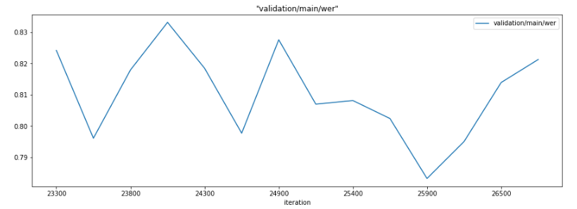
Fig. #. .

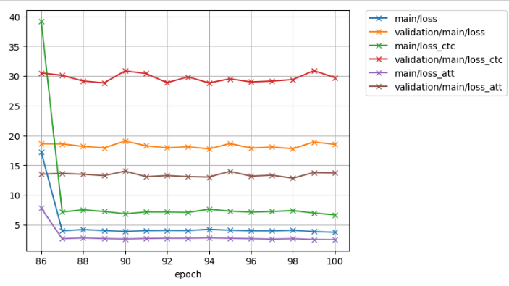
Fig. #.
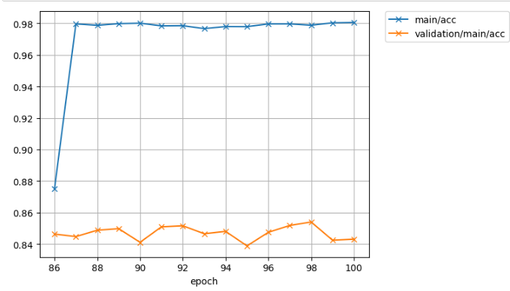
Fig. #. .
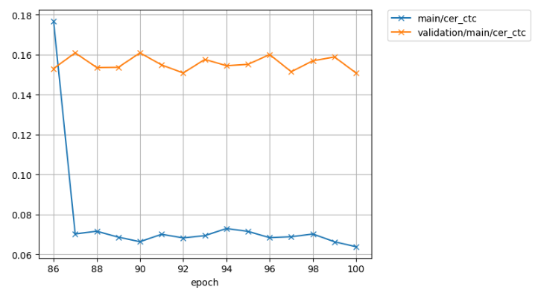
Fig. #. .
There are no signs of overfitting in Spanish common voice after 100 epochs

  - Plots for “Gong unsupervised”

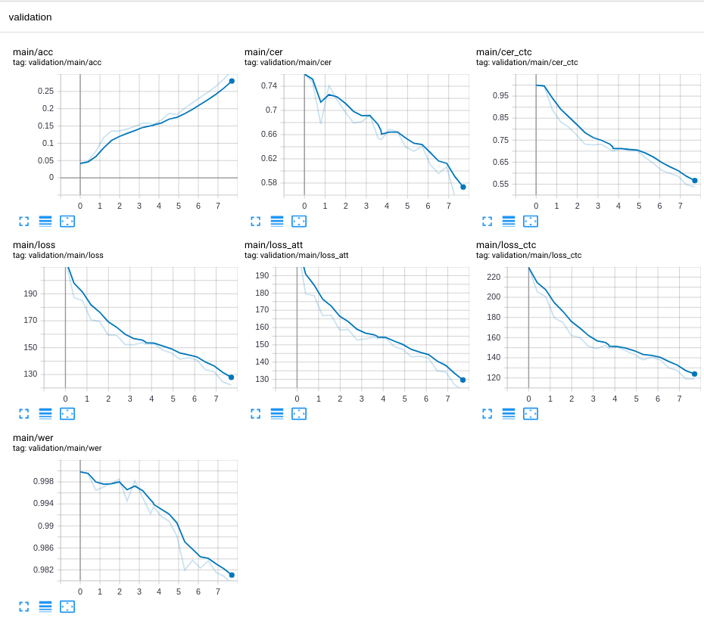
Fig. #. 10 second epochs on tensorboard.

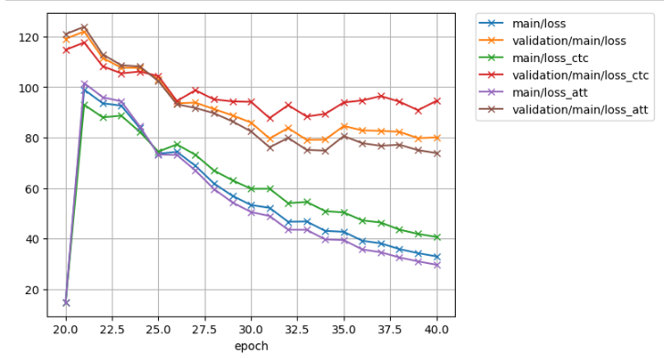
Fig. #. .
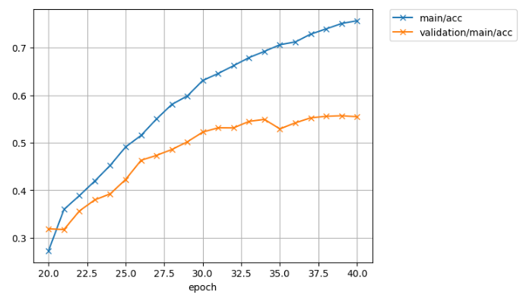
Fig. #. .

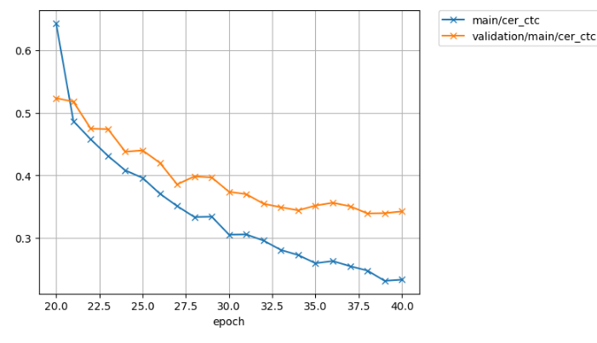
Fig. #. .
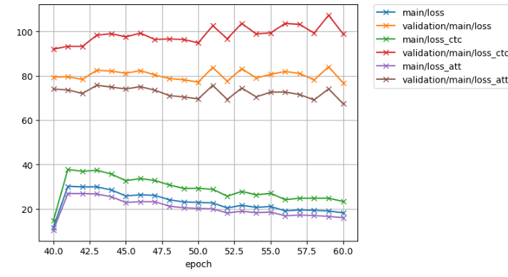
Fig. #. .
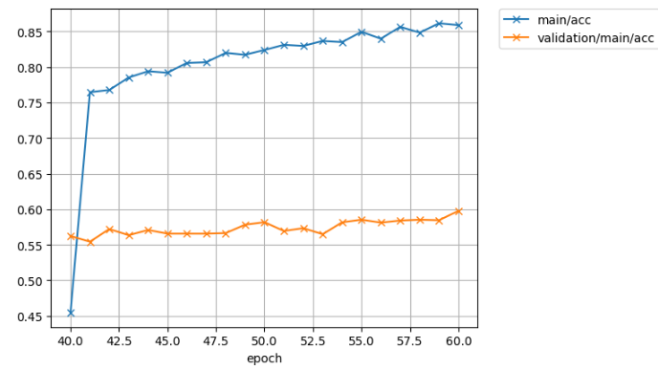
Fig. #. .
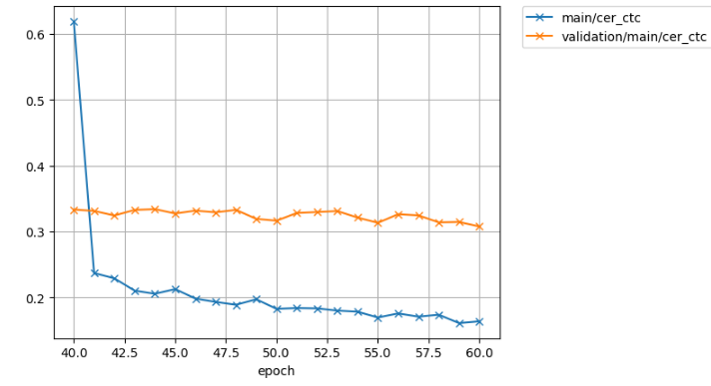
Fig. #. .
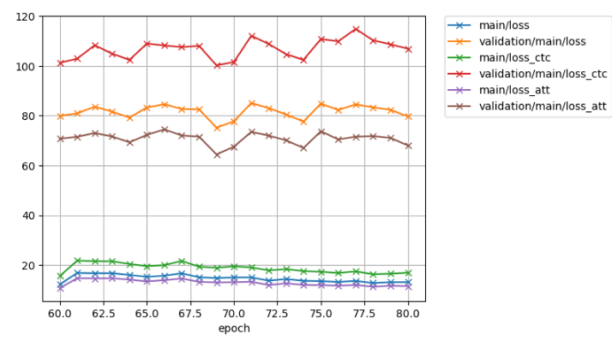
Fig. #. .
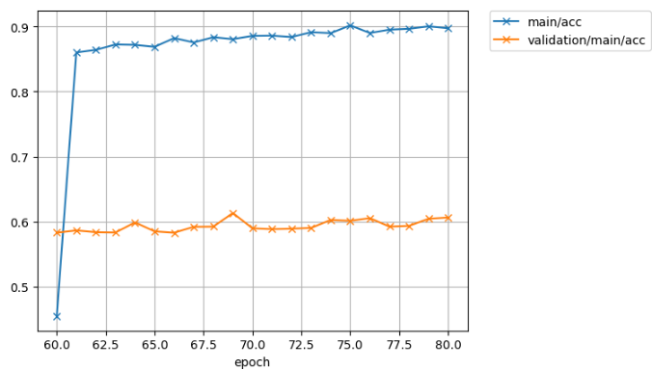
Fig. #. .
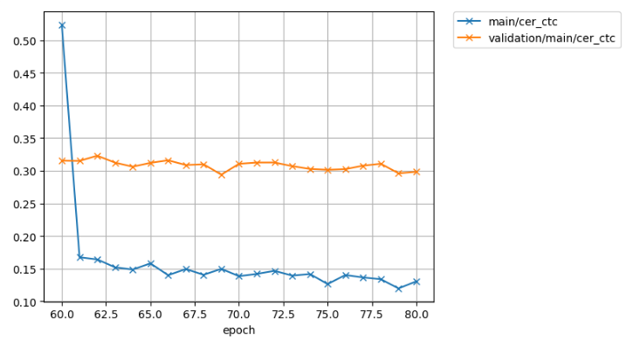
COMMON VOICE with SubWords from Gong-Unsupervised
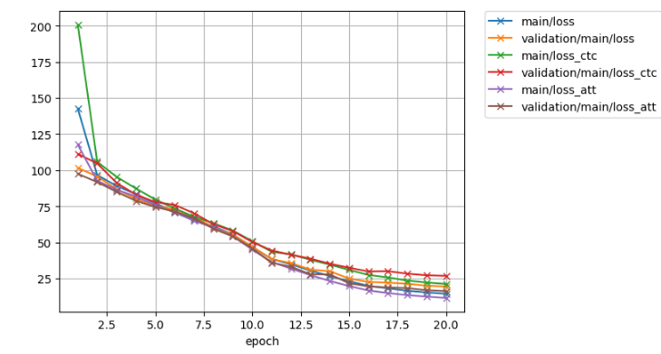
dsf’;gskd’fg
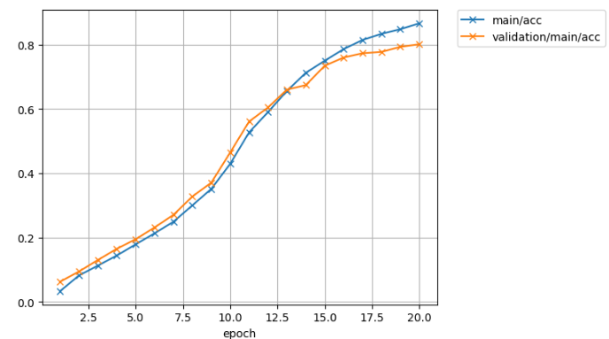
sdfgksd’fg;
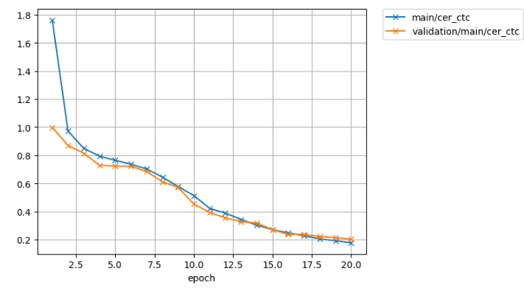
sdfgs’d;flgk
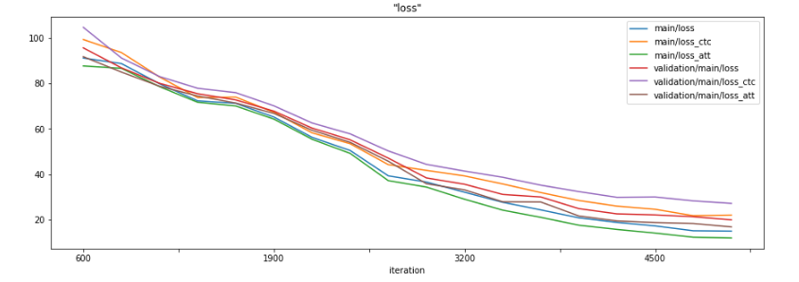
sd’f;glsdk’fg;l
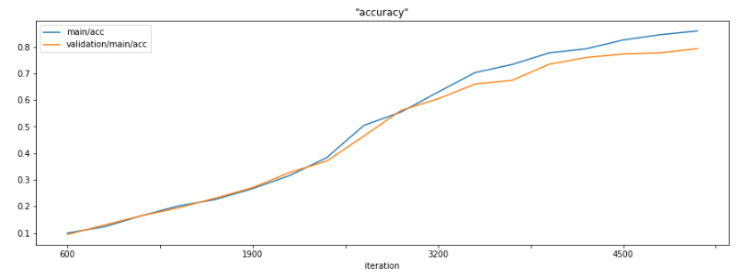
s’df;lgks’df;gs
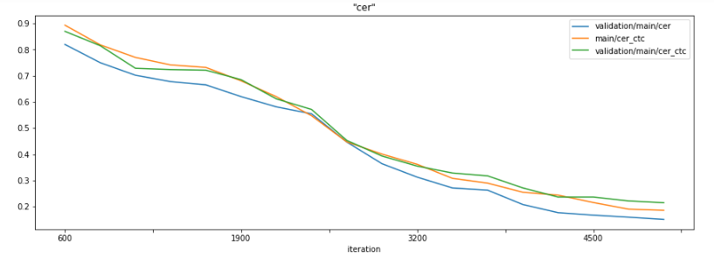
sdf’;lgksd’f;glk
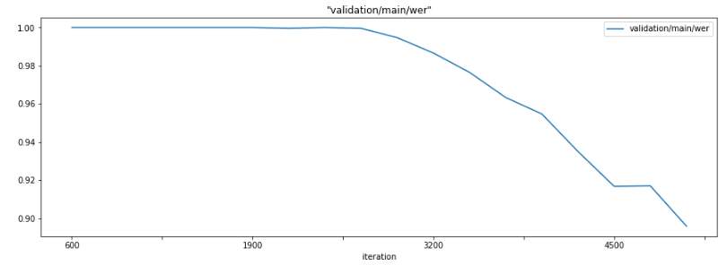

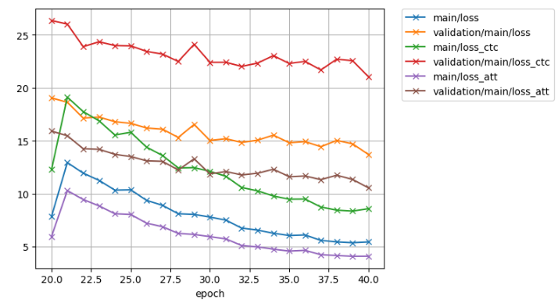
df;slkdfgs;lkg
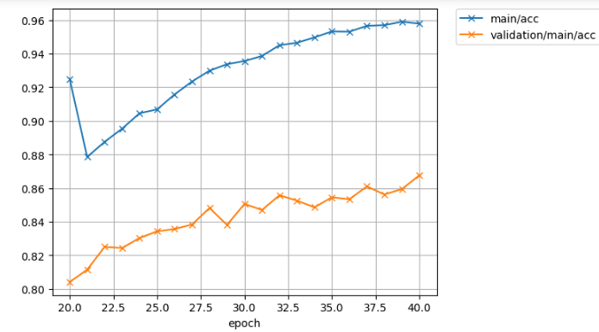
sdf;gsd;fglkjf
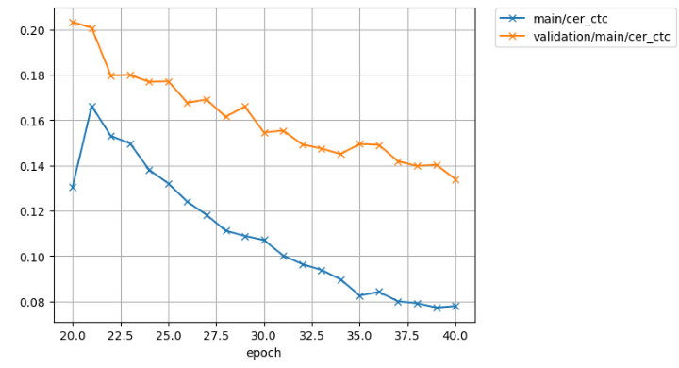
sd;flgkds;gflsjk
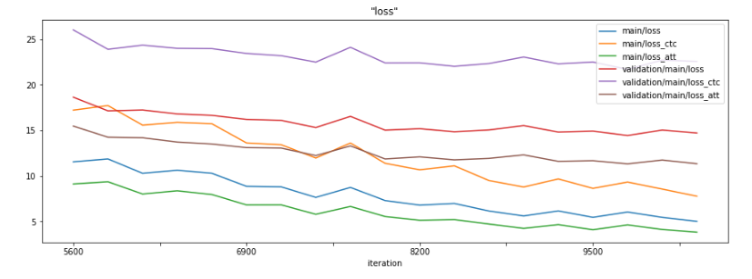
sd;flkgsjf
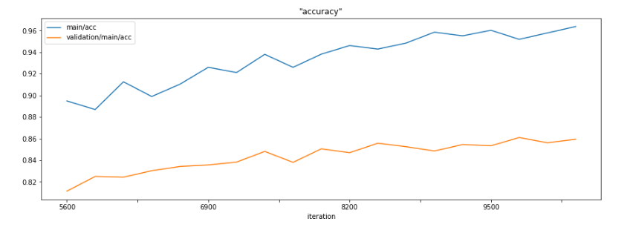
dsfgsklgfj
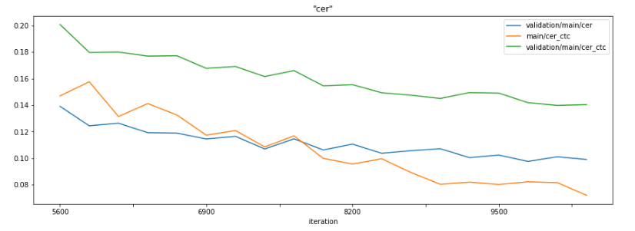
sdfgsfg
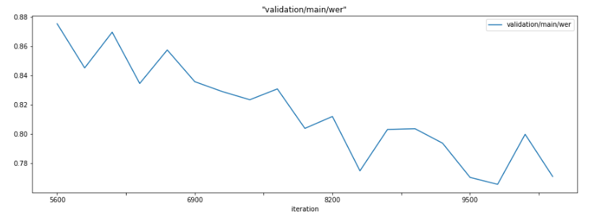
dfgdfgdgf
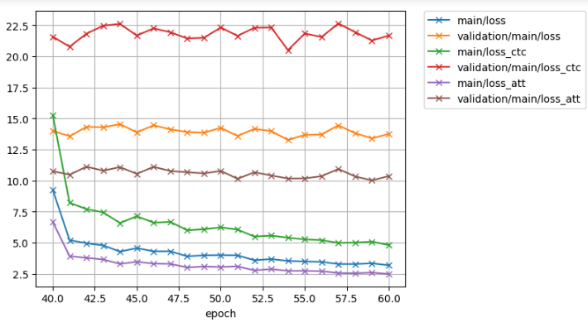
dgsdfgsdf
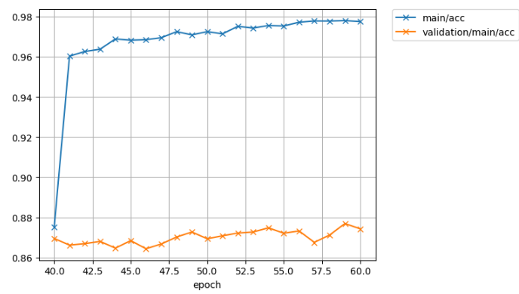
dsfsgdkf;sglk
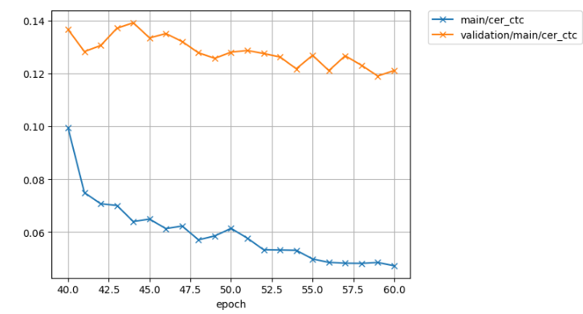

sdfglsdkfg;sdlfg
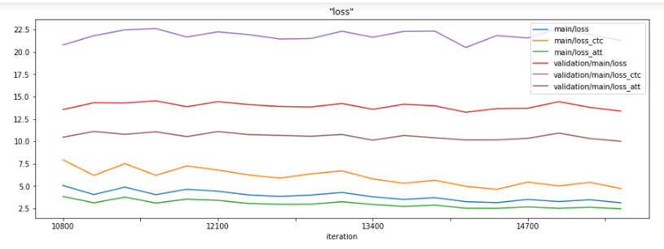
df’;gdlf’g
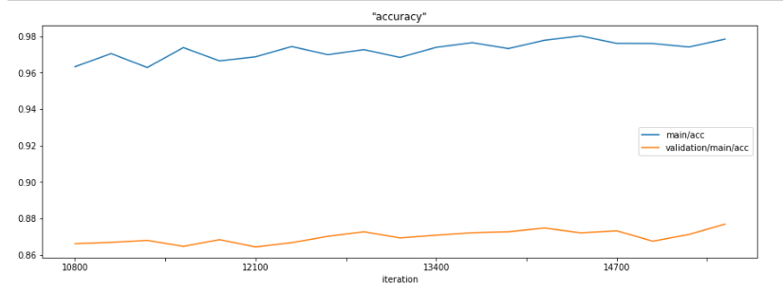
df’s;lgksd’;fgls
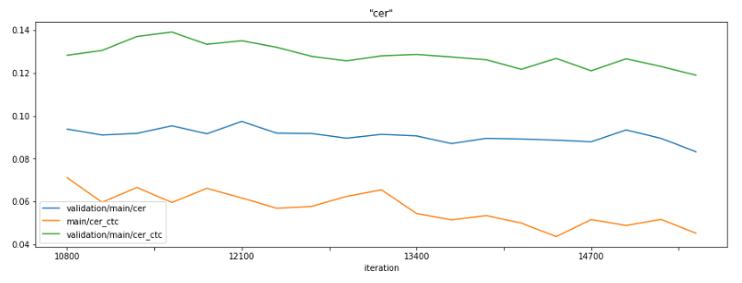
dsf;glkds’fg;k
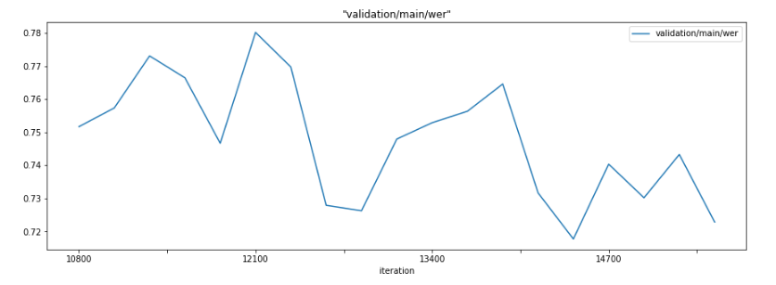

dsfgsdkf’g;sdkgf’lk
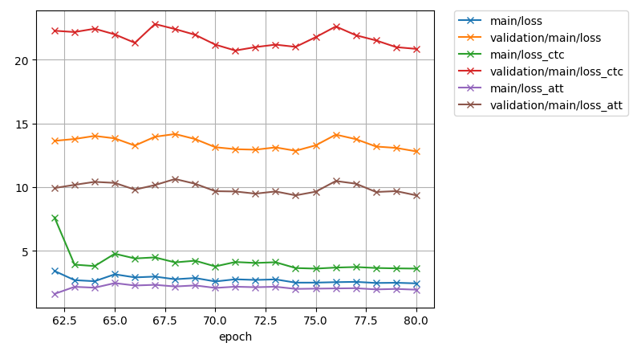
dsfgsldgf’s;dl
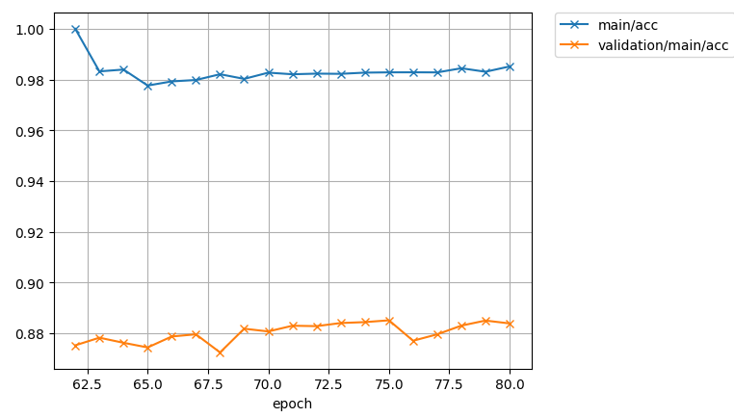
dsf’gs;dlkgs’d;fg

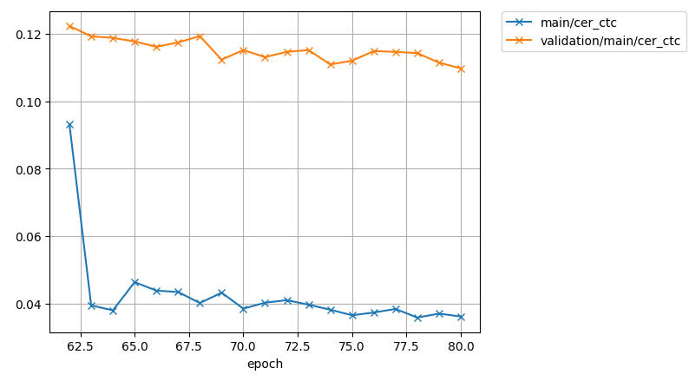
dfgs’df;glksd’fgk
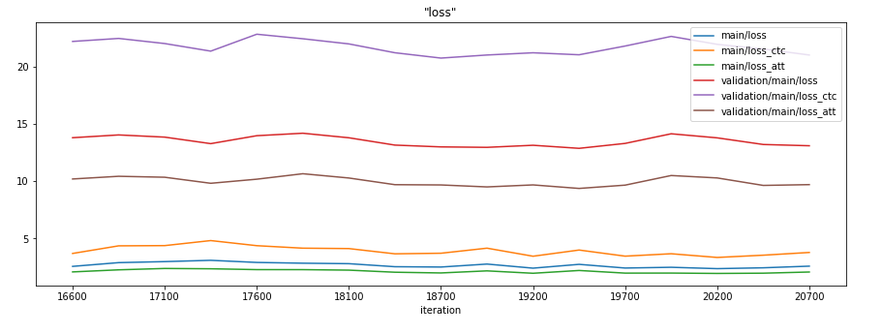
sfdgs’;dlfgks’df
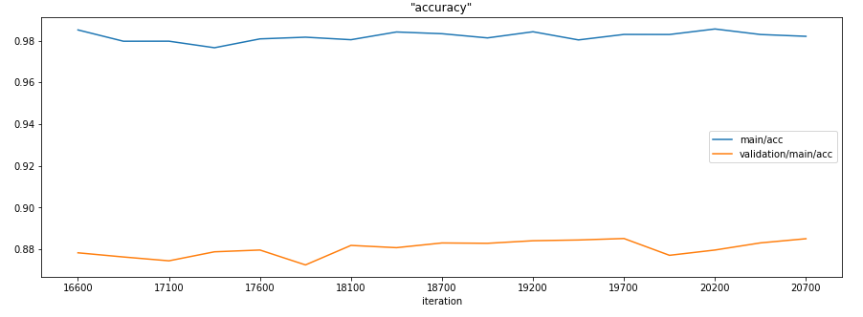
sdfglsd’fg;lsd’fg
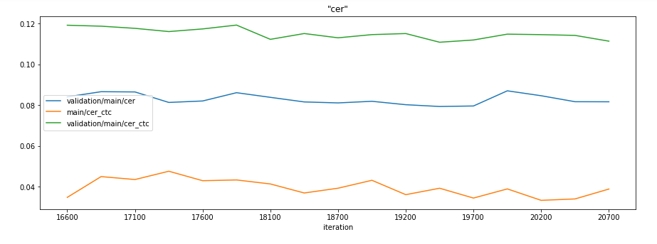
df’gl;sdkfg’
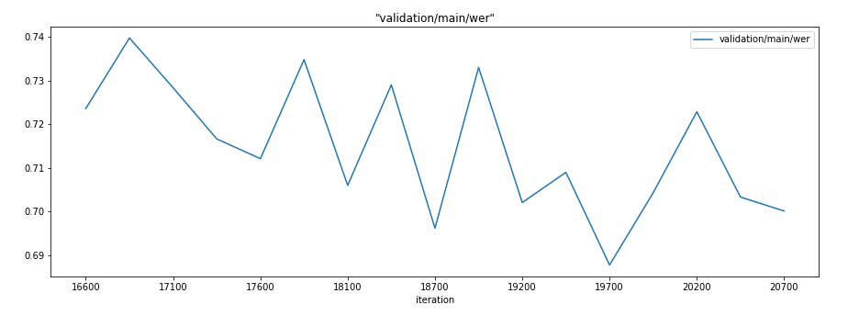

We have not find sings of overfitting of our AM in any setup!!!
References
- “Towards End-to-End Speech Recognition with Recurrent Neural Networks”, Graves et al., 2014
- “SPEECH RECOGNITION WITH DEEP RECURRENT NEURAL NETWORKS”, Graves et al., 2014
- “Attention-Based Models for Speech Recognition”, J Chorowski et al, 2015
- “Attention Is All You Need”, A. Vaswani et al.
- “The Annotated Transformer”, A. Rush, et al. (http://nlp.seas.harvard.edu/2018/04/03/attention.html)
- “A COMPARATIVE STUDY ON TRANSFORMER VS RNN IN SPEECH APPLICATIONS”, S. Karita et al. (the authors are contributed the Transformer-based ASR into ESPnet)
- “End-to-end speech recognition with word-based rnn language models”, T. Hori et al. 2018
- “Improving Transformer-based End-to-End Speech Recognition with Connectionist Temporal Classification and Language Model Integration”, S. Karita et al.
- “JOINT CTC-ATTENTION BASED END-TO-END SPEECH RECOGNITION USING MULTI-TASK LEARNING”, S. Kim et al.
- “Joint CTC/attention decoding for end-to-end speech recognition”, T. Hori et al.
- “Advances in Joint CTC-Attention based End-to-End Speech Recognition with a Deep CNN Encoder and RNN-LM” T. Hori et al.
- “Effective Approaches to Attention-based Neural Machine Translation”, M Luong et al (2015)
- “The Challenges of using Transformers in ASR”, D. Raj (https://desh2608.github.io/2020-01-08-transformer-asr/)
- “Neural Machine Translation of Rare Words with Subword Unit”, R. Sennrich et al. (introduced BPE)
- “TRANSFORMER-BASED ACOUSTIC MODELING FOR HYBRID SPEECH RECOGNITION”, Y Wang, et al. (“Though compared with the sequence-to-sequence or neural transducer architecture, the hybrid approach is admittedly less appealing as it is not end-to-end trained, it is still the best performing system for authors’ practical problems. It also has the advantage that it can be easily integrated with other knowledge sources (e.g., personalized lexicon) that may not be available during training. In this work, we aim to leverage the transformer to improve hybrid acoustic modeling”)
- “Subword Regularization: Improving Neural Network Translation Models with Multiple Subword Candidates”, T.Kudo.
- “SPEECH-TRANSFORMER: A NO-RECURRENCE SEQUENCE-TO-SEQUENCE MODEL FOR SPEECH RECOGNITION”, L. Dong et al.
- “Tensor2Tensor for neural machine translation”, A. Vaswani et al.
- “The Kaldi speech recognition toolkit”, D. Povey et al.
- “Training Tips for the Transformer Model”, M. Popel et al.
- “Connectionist temporal classification: Labelling unsegmented sequence data with recurrent neural networks”, A.Graves et al.
- “A pitch extraction algorithm tuned for automatic speech recognition”, P. Ghahremani et al.
- “STREAMING AUTOMATIC SPEECH RECOGNITION WITH THE TRANSFORMER MODEL”, N. Moritz et al.
- “SentencePiece: A simple and language independent subword tokenizer and detokenizer for Neural Text Processing”, T. Kudo, J. Richardson
- “Recurrent neural network based language mode”, T. Mikolov et al.
- “Scaling Neural Machine Translation”, M. Ott et al.

- “STREAMING AUTOMATIC SPEECH RECOGNITION WITH THE TRANSFORMER MODEL” N. Moritz
- “Triggered attention for end-to-end speech recognition” N. Moritz
- “Speech recognition for medical conversations” CC Chiu et al. (ASR with noisy transcripts)

